Initial Project Proposal

Year: 2023 Semester: Fall Project Name: Smart Air Hockey Table

Creation Date: April 27, 2023 Last Modified: August 23, 2023

Team Members (#1 is Team Leader):

Member 1: Alan Chung Ma Email: achungma@purdue.edu

Member 2: Benjamin Owen Email: owen67@purdue.edu

Member 3: Trevor Moorman Email: tmoorma@purdue.edu

Member 4: William Dobert Email: wdobert@purdue.edu

1.0 Description of Problem:

A recent rise of nostalgia amongst the population is driving an increase in sales of arcade games [1]. Air hockey, which gained popularity during the arcade boom of the 1980s [2], is also set to grow from the aforementioned trend and the market for air hockey tables is set to grow over the next decade [3]. The fastest growing segment of the air hockey market is tabletop air hockey tables [4], aimed at households buying a game to play at home. We propose a modernized tabletop air hockey table that will offer comparable playing experience with competing tables with enhanced game feedback and electronic features that are more commonly found in arcade-style air hockey tables.

2.0 Proposed Solution:

The proposed tabletop air hockey table will differ from its competitors by having an array of full color LED lights under a translucent playing surface. The lights will provide a pleasant under-glow and react to the position of the playing puck. Automated score tracking will also be handled and displayed on a central display. Potential solutions for puck position tracking include hall effect sensors, inductive sensing, and computer vision. Since the position of the puck will be known at all times, there will be an option to program different game modes that can be selected with a knob. In order to make sure that all of the electrical components fit beneath the playing surface, a custom air hockey table would be designed and built. Retrofitting an existing commercial air hockey table for this project does not seem reasonable as it would involve adapting an intricate system to our needs.

3.0 ECE 47700 Course Requirements Satisfaction

*There will be a total of two embedded units designed, each with a PCB, microcontroller and corresponding sensors and interfaces. The main unit will keep track of the game state and control the game display. The other unit, which we will call the subsurface unit as it will be placed under the playing surface, will be a module that houses all sensors used to track the puck and LEDs, multiple subsurface units will be chained in a matrix under the playing surface in order to obtain full coverage. The main unit will need to be able to communicate with the subsurface units to control the LEDs and track the position of the puck.*

3.1 Expected Microcontroller Responsibilities

Since there will be two microcontrollers, each in the corresponding embedded unit described in 3.0, their responsibilities will be split accordingly. The microcontroller that will reside in the main unit will be in charge of calculating the position of the puck from the compressed sensor data from the subsurface units, control the LED matrix, control the display, track game score and control game state if running under different game rules. The subsurface unit microcontrollers will be in charge of collecting and compressing sensor data and controlling the unit’s corresponding LEDs.

3.2 Expected Printed Circuit Responsibilities

Similar to section 3.1, responsibilities will be split amongst both embedded units which will be designed, but both will hold microcontrollers, have a shared responsibility to distribute power amongst all boards, sensors, and microcontrollers, and house an array of connectors so that they can communicate with each other. The main unit PCB will also have a connector to the display, goal sensors, and an external control knob. The subsurface units will additionally house the RGB LEDs and sensors for puck tracking. More specifically, we expect to use the SPI interface to communicate between the various sub-PCBs in our design due to its high speed and reliability. Furthermore, the PCB may include sensors to help track the position of the air hockey puck while it moves around the table. These sensors will be interfaced with smaller, cheaper microcontrollers, who will then report to higher “master” controllers in order to avoid direct multiplexing of hundreds of sensors by a single processor. This design also allows for the use of analog sensors as the data can be processed locally, and a digital representation can be sent back to the master over the SPI buses.

4.0 Market Analysis:

Because of the modularity of our design and potential for custom development in the future, the target market is very wide. The obvious choices are arcades and other companies who want to purchase an air hockey table for patrons, but smaller tables are popular for general consumers. Established air hockey table companies such as Brunswick and Valley-Dynamo are more focused on general air hockey table aesthetics rather than innovating and improving the user experience [18]. Because of the potential for custom games, our table will fill both the commercial and residential market spaces. Variations of the table size would allow for arcade-style tables and tabletop versions for various environments. The global air hockey table market is expected to experience significant growth [19], driven by factors such as rising disposable income, rapid urbanization, and the increasing popularity of recreational activities. Arcade-style air hockey tables are likely to gain significant traction due to their high durability. The increasing number of kid-friendly gaming centers and arcades is expected to drive demand for basic design air hockey tables. The emergence of robotic air hockey tables is anticipated to be the new trend in the market, while DIY air hockey tables may restrain the market's growth potential. North America and Europe are expected to account for a larger market size, while Asia will likely experience higher growth [19] due to countries such as China and Japan driving the market's growth with lower manufacturing costs, new trends, and technological changes.

5.0 Competitive Analysis:

The overall idea of an air hockey table is not new by any stretch. Instead, our differences come from the innovation and extra features added onto the existing table designs. Patents exist for vague features that may have similarities to parts of our improvements, but no existing air hockey table currently on the market has even a majority of the features we are implementing in our design. By adding all of these new features such as custom lighting, custom gameplay, and robust puck location detection, as well as an open-source design that allows for custom games to be added in the future, our table will exist in its own segment in the air hockey market. We will have very little existing intellectual property to work around, and if we are successful with our development, we will have created a unique experience that has not been seen before in the air hockey space.

5.1 Preliminary Patent Analysis:

The team’s preliminary analysis of potentially competing patents found that alternative mechanisms for achieving our desired features exist, however the team was unable to find any patents which utilized the mechanisms in a similar context to our proposed solution. The patents describe solutions which require large structures to be attached to the air hockey table. These large structures already pose a large disadvantage compared to our proposed design, as the structures reduce the design’s flexibility in scaling to different sizes for different applications. Furthermore, none of the patents the team found described having capabilities that match the goals of the team. A comparison of these alternative mechanisms and our proposed solution will be discussed further below.

5.1.1 South Korea Patent KR102002006B1

Fig. 1. Rendering of Proposed Design with Analytical Screens

This patent [5] describes an air hockey table that includes the key feature of tracking the location of the puck and pushers throughout play. However, this application of this data differs greatly from our proposed design. The location data of the puck and pushers are included in an analytical image of goals that may include “an attack angle of the pusher, an attack speed of the pusher, a reflection angle of the puck after collision, and a movement time of the puck after collision” [5]. Furthermore, the data is described as an “estimate” [5] which suggests the data would not be accurate enough for our planned use cases. Overall, the inventors intend to create an air hockey table that offers an enhanced visual experience for spectators and practicing athletes.

5.1.2 South Korea Patent Application KR20200008198A

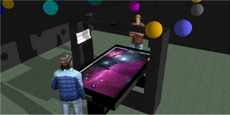

Fig. 2. Rendering of Proposed Design including Frame for Sensor and Projector

Similar to the patent previously described in section 5.1.1 [5], this patent [6] describes an air hockey table which is capable of tracking the location of the puck and pushers. This data is also used to provide related “visual and auditory effects at the same time to make the game more interesting” [5]. However, these visuals are displayed via the playing field of the air hockey table itself. The playing field of the air hockey table is described as a touch screen which can fill the entire picture space of the picture frame. A similar such design will be discussed in sections 5.2.2 and 5.2.3 which fully digitizes the air hockey. While the suggested tracking data seems more accurate, the use of this data and the air hockey table’s surface differs greatly from our proposed project.

5.1.3 US Abandoned Patent US20070164510A1

This patent [7] seeks to innovate by coordinating the sounds and lights present in prior air hockey table designs with the gameplay. The idea of better incorporating the audio and visual feedback from the air hockey table with the gameplay mimics our proposed project. However, the patent [7] is limited in its scope of audio and visual feedback with describing simple reactions to particular actions within the game. Our proposed project seeks to further the limits of this feedback using the gathered data on the position of the puck and pushers.

5.2 Commercial Product Analysis:

The team's initial commercial analysis of currently available air hockey tables found little innovation within the market. Products are primarily classified based on their size. Products then differentiate by catering to distinct styles and offering varying balances between price and quality. An example of such will be further discussed in section 5.2.1. The team will keep in mind these differences when considering the target demographic of our proposed design. Given that the team was unable to find a commercial air hockey table with puck tracking, further commercial analysis focused on commercially available sensors. Section 5.2.2 and section 5.2.3 provide an analysis of object tracking using a hall effect sensor and camera, respectively. These analyses will serve as a preliminary examination into the feasibility of each sensor within the context of the proposed project.

5.2.1 Commercial Product #1:

Fig. 3. Fire Storm

Valley-Dynamo is a dominant player in the coin-operated and home markets of several large table games, such as pool, foosball, and air hockey. Valley-Dynamo’s most advanced coin-operated and home air hockey table is the Fire Storm [8]. As described by Valley-Dynamo, the Fire Storm includes a simple to program and access PCB, adjustable game sounds, interactive multi-color LED lighting, and a black-lit reactive trim and graphs. Besides advertising the high-grade construction, Valley-Dynamo primarily focuses on the aesthetic advancements to distinguish the Fire Storm from other air hockey tables. This further supports the team’s assertion that, besides distinctive decorations, innovation within the air hockey table market has stagnated. The only core gameplay features the Fire Storm boasts is a quality blower system and jam-proof infrared scoring. While the team will be unable to match the manufacturing quality of Valley-Dynamo, the team can study these two components to ensure our fundamental table design is capable of achieving the existing quality in the market.

5.2.2 Commercial Product #2:

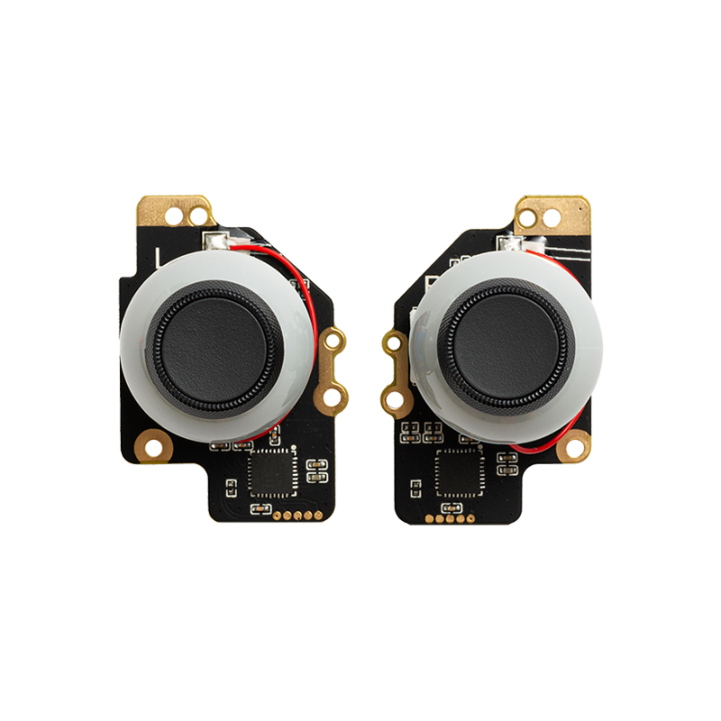

Fig. 4. Steam Deck Hall Effect Joystick

GuliKit provides replacement joystick modules for a number of video game controllers which use hall effect sensors as opposed to traditional potentiometer designs [9]. Potentiometers, which work due to a physical connection between pieces of conductor, wear out with use due to the constant friction which is inherent to the design. This can lead to something called “joystick drift,” which results in a neutral-positioned joystick reading as an input. Hall effect-based designs, however, use magnets and hall effect sensors to detect the position of the joystick without any mechanical wear on the components. Because of the contactless design, GuliKit advertises smoother operation and no joystick drift as the product is used [10]. In addition to longer life, they also advertise more accuracy compared to the original potentiometer-based designs. Specifically, on their Steam Deck replacement joystick modules, they advertise ±3 degree accuracy compared to the OEM ±5 degree accuracy [10]. Products such as the ones offered by GuliKit prove that accurate position tracking is possible with hall effect sensors, and that the precision may be possible to be expanded into a two-dimension plane, such as embedded in a table. The team will need to ensure that this precision can be preserved with the increased distance of the table playing surface itself. Software will also need to be developed to ensure that the position of objects on the table can be tracked with precision as the puck moves along the surface. Furthermore, as gaming becomes more fast-paced, it is necessary that these joystick modules have low latency, proving the effectiveness of hall effect sensors in an environment such as a controller. The team will need to ensure that this property is preserved when implemented into a much larger scale.

5.2.3 Commercial Product #3:

Fig. 5. Optitrack’s SlimX 13

Optitrack provides cameras, software, and related accessories for motion capture and high-speed object tracking [11]. Optitrack's products provide features not required for our proposed project and are outside of our financial scope. However, Optitrack's products can be used as a benchmark for computer vision's feasibility within the context of our proposed project. Our commercial analysis will focus on Optitrack's SlimX 13 using information available from the product page [12] and product comparison page [13]. The SlimX 13 has a minimum frame rate of 240 fps, which Optitrack claims is capable of tracking objects moving up to 125 mph [12]. Using 80 mph as a rough estimate for the top speed of an air hockey puck during play [14], the SlimX 13 can track the puck. However, the SlimX 13 has a latency of 4.2 ms [13], which means the puck may move up to ~15 cm before location data can be transmitted from the SlimX 13. The location discrepancy would make real-time applications using the puck's location data infeasible. This limitation could be improved using software to predict the puck's path given that air hockey pucks typically move in straight lines. Furthermore, given the reduced capabilities required by the camera for the proposed project, latency may be able to be reduced. Thus, the team will need to be cognizant of latency introduced by hardware and may need to develop software to diminish latency's impact on our proposed project.

5.3 Open Source Project Analysis:

There is a relatively limited number of comparable open source projects that implement the feature set the team intends to include in our own project. The team focused on investigating three projects of varying technical complexity. These projects serve as an indicator of what individuals and small teams have achieved up to this point in time.

5.3.1 Open Source Project #1:

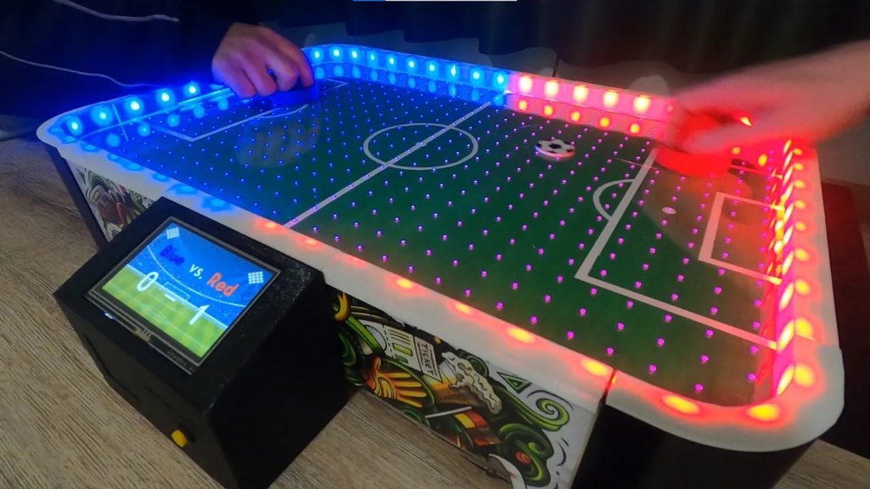

Fig. 7. Demonstration of Assembled Game Board in Action

The first major open source project the team researched is a tabletop, Arduino-powered air football game [19]. It was created by Silas Hansen and all files necessary to recreate it were published to an Arduino Project Hub. This open source project is not assigned any explicit license by its sole creator, but it is subject to all licenses associated with Arduino projects. The game maintains scoring by detecting when the puck is in either goal via infrared proximity sensors. The perimeter lights are illuminated with the scorer’s color each time a goal is made. This serves as an engaging visual indicator to both players and makes effective use of the capabilities provided by an onboard microcontroller. The attached 4.3-inch color screen is updated via UART to reflect the new score anytime a goal is made. Compared to the team’s project, discussed above, this project focuses on the physical construction of the device, and less so on programming or solving a major design challenge, such as object tracking or multiple-device intercommunication.

5.3.2 Open Source Project #2:

Fig. 8. Rendering of Fully Assembled Playfield

The team also investigated an alternative that has similar functionality to the project discussed in 5.3.1. DIY Low Cost Air Hockey Table is an Instructables project created by Kousheek Chakraborty and Satya Schiavina [16]. It was published with a full bill of materials and all associated 3D models and Arduino code available for download. This project doesn’t utilize any sensors or have any reactive elements, and instead relies on the players to manually increment their score whenever a goal is made. The isolated scorekeeping module is controlled by an Arduino board, and the attached LCD screen is communicated with via I2C. LED lighting strips are embedded on either side of the gameboard, and are set to a single color at all times. The most difficult aspect to recreating this project would be assembling the device, as the creator utilized soldering, carpentry, 3D printing, and laser cutting. In contrast to the team’s project, this open source project has a fairly limited scope in terms of interactivity.

5.3.3 Open Source Project #3:

Fig. 9. Live Exhibition of OpenPool

The final open source project the team chose to investigate is OpenPool [17]. OpenPool projects a reactive image onto a billiard table to enhance the playing experience. In contrast to the previously investigated open source projects, and the team’s own project, OpenPool uses fairly high-level technologies to achieve functionality. The projected image comes from a connected desktop computer, which renders it in the Unity game engine. The state of the table is obtained by processing the feed from a mounted Kinect 2 with OpenCV. Each distinct module of OpenPool has its own licenses, but generally the project falls under GPLv3. In terms of scope of interactivity, this open source project is the closest out of all investigated projects to what the team intends for our project to achieve. It has major similarities to the team’s project, such as reacting to game elements in a tabletop environment. However, the technical implementation differs greatly, as OpenPool was designed to be an add-on to existing billiards tables. The team will not be able to directly utilize anything created for OpenPool, as the team’s design is meant to be a fully integrated solution.

6.0 Sources Cited:

[1] David B. Feldman (2022). Why Nostalgia is on the Rise. Available: [www.scu.edu/illuminate/thought-leaders/david-b-feldman/why-nostalgia-is-on-the-rise.html](http://www.scu.edu/illuminate/thought-leaders/david-b-feldman/why-nostalgia-is-on-the-rise.html)

[2] Business Wire (2016). Global Air Hockey Table Market 2016-2020 - Rising Popularity of Air Hockey Tournaments - Research and Markets. Available: [www.businesswire.com/news/home/20160719006412/en/Global-Air-Hockey-Table-Market-2016-2020---Rising-Popularity-of-Air-Hockey-Tournaments---Research-and-Markets](http://www.businesswire.com/news/home/20160719006412/en/Global-Air-Hockey-Table-Market-2016-2020---Rising-Popularity-of-Air-Hockey-Tournaments---Research-and-Markets)

[3] Syndicated Analytics (2021). Global Air Hockey Table Market: Industry Analysis, Market Size, Share, Trends, Application Analysis, Growth and Forecast, 2022-2027. Available: [www.syndicatedanalytics.com/air-hockey-table-market](http://www.syndicatedanalytics.com/air-hockey-table-market)

[4] Business Wire (2017). Global Air Hockey Table Market - Size, Projections, Drivers, Trends, Vendors, and Analysis Through 2021 by Technavio. Available: [www.businesswire.com/news/home/20170628005973/en/Global-Air-Hockey-Table-Market---Size-Projections-Drivers-Trends-Vendors-and-Analysis-Through-2021-by-Technavio](http://www.businesswire.com/news/home/20170628005973/en/Global-Air-Hockey-Table-Market---Size-Projections-Drivers-Trends-Vendors-and-Analysis-Through-2021-by-Technavio)

[5] 김근태, 나태형, 박지용 (2019). Hybrid air hockey game apparatus and its control method. Available: [patents.google.com/patent/KR102002006B1/en](https://patents.google.com/patent/KR102002006B1/en)

[6] 나태형 (2020). Dynamic air-hockey using a interactive mapping technology. Available: [patents.google.com/patent/KR20200008198A/en](http://patents.google.com/patent/KR20200008198A/en)

[7] Chien-Yeh Chen (2007). Game table with sounds and lights coordinated to game action. Available: [patents.google.com/patent/US20070164510A1](http://patents.google.com/patent/US20070164510A1)

[8] Valley-Dynamo LP, Fire Storm. valley-dynamo.com. [www.valley-dynamo.com/fire-storm-coin](http://www.valley-dynamo.com/fire-storm-coin) (accessed May 5, 2023).

[9] GuliKit. “GuliKit”. Gulikit. [www.gulikit.com/](http://www.gulikit.com/) (Aug. 23, 2023)

[10] GuliKit. “GuliKit Electromagnetic Joystick Module for Steam Deck”. GuliKit. [www.gulikit.com/productinfo/1026071.html](http://www.gulikit.com/productinfo/1026071.html) (Aug. 23, 2023)

[11] Optitrack. “Optitrack - Motion Capture Systems”. Optitrack. [www.optitrack.com/](http://www.optitrack.com/) (Aug. 22 2023)

[12] Optitrack. “Optitrack - SlimX 13”. Optitrack. [www.optitrack.com/cameras/slimx-13/](http://www.optitrack.com/cameras/slimx-13/) (Aug. 22 2023)

[13] Optitrack. “Optitrack - Optitrack Compare Cameras”. Optitrack. [www.optitrack.com/cameras/compare/](http://www.optitrack.com/cameras/compare/) (Aug. 22 2023)

[14] Adam (2022). “How Fast Can A Hockey Puck Travel?”. Silver Skate Festival. [www.silverskatefestival.org/how-fast-can-a-hockey-puck-travel/](http://www.silverskatefestival.org/how-fast-can-a-hockey-puck-travel/) (Aug. 22 2023)

[15] “This homemade table puts a soccer spin on air hockey,” Arduino Blog, Mar. 02, 2022. [blog.arduino.cc/2022/03/02/this-homemade-table-puts-a-soccer-spin-on-air-hockey/](http://blog.arduino.cc/2022/03/02/this-homemade-table-puts-a-soccer-spin-on-air-hockey/) (accessed May 07, 2023).

[16] K. Chakraborty and S. Schiavina, “DIY Low Cost Air Hockey Table,” Instructables, Aug. 22, 2019. [www.instructables.com/DIY-Low-Cost-Air-Hockey-Table/](http://www.instructables.com/DIY-Low-Cost-Air-Hockey-Table/) (accessed May 07, 2023).

[17] J. Kato, OpenPool, Jul. 21, 2013. [openpool.cc](http://www.openpool.cc/) (accessed May 08, 2023).

[18] Valley-Dynamo LP, Dynamo Air Hockey. valley-dynamo.com.

[www.valley-dynamo.com/dynamo](https://www.valley-dynamo.com/dynamo) (accessed August 22, 2023).

[19] Fact.MR – air hockey table market - Global Review 2018 to 2028. Fact.MR, Market

Research Company. (n.d.). [www.factmr.com/report/999/air-hockey-table-market](http://www.factmr.com/report/999/air-hockey-table-market) (Accessed Aug 23, 2023)

Appendix 1: Concept Sketch

